2015
Law Enforcement
Trainers Association
World Cup
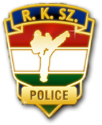

Amateur and Pro Invited Opened Tournament

The organizer of the tournament:
Energy Gold Future Limited Malta
Organising committee:
E-mail :info@energygold.eu , Tel: +356 79252246
The time of the tournament: 7th of March 2015 Saturday

A planned starting time:

10.00 am, 7th of March 2015 Saturday

Registration: 08.00-09.30 / 7th of March, Saturday

A location of the tournament:

Malta

The President of the Tournament:

Geza Gyorki Dr. 7. dan

The Main Patron of the Tournament:

Patrons:
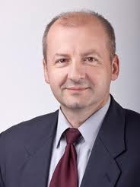
István Simicsko sport parliament secretary
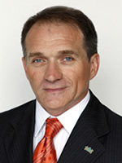
János Bácskai Dr. Parliament – IX. Discreet Major
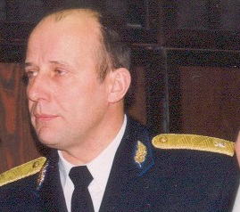
Istvan Komaromi Dr. Main Academy instruct
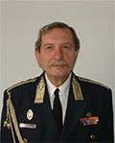
Frigyes Janza Prof Dr. Academy Ministry of main Mayorable,
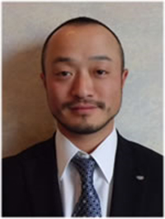
Hanshi Obi Morosita 9.dan Japan karate Federation Vice president
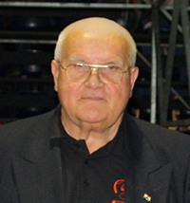
Hanshi Antal János 9.dan

The Main Judge of the Tournament:
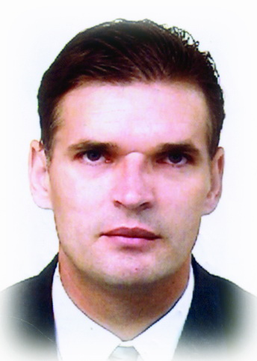
Shihan Rab Sándor RKSZ Főinstruktor 6. Dan

Self defence
Group of ages:
From 10-14 years old
From 14-18 years old
Adults:
We keep up the right according the applications, we might be change the categories for example: 6-8 years old, 8-10 years old, 10-12 years old...etc

Categories:

Group Tournament:
3 people self defence presentation

Individual Self defence:
The partner can ask the attacker to fight within the same style.

According the levels and skills:
Amateur/Lerner
Professionals/ Masters

The conditions of the participant:
All the sporting can take part in the tournament, who have been invited and accepted the terms and conditions. Also she/he has a membership with any sport school and he/she can prove it. You need to have a valid medical certificate as well from the sport doctor. If you don’t have you can make it at the location of the tournament. The sporting have to take cares about the neatly, clean clothing and tools. If you are coming in non accepted clothing, the consequences might be have foreclosure as well.

A deadline of the application:

4th of March, 2015 (24 hours before)

If you applicant after the deadline, we accept only in exceptional cases.

Fees of the application:
1 Category: 10 euro,
2 Category: 17 euro
3 Category 25 euro

If you apply locally, it has a higher charge 15 euro per category!

Tickets:

For the visitors the tournament is FREE!

The Doctor of the tournament: In Progress...

The condition of the application
You can apply by email:
or SMS:

Medal Ceramony:

V. Rank Certification
IV. Rank Certification
III. Rank Certification+ medal
II. Rank Certification +medal
I. Rank Certification+medal+Cup

The most successful Team will receive the Cup of The Tournament at the end.

The catering will be provided by the organizer company on a discounted price.

Timing:
Saturday
09.00 – 09.50: Arrival, Registration
From 09.50am: Introduction of the Teams, Anthem, Opening ceremony, Speaches
From 10.10am: Intorduction of the rules
From 10.20am. Starting the children Categories
From12.00pm: Starting the Adults Categories
13.00 – Lunch
18.30 – Medal ceremony of the children categories
20.30 21.00 –Closing
21,00 20,00 International Gala
Sunday
From 10.10am: Introduction of the rules
From 10.20am: Children Categories
From 12.00pm: Adult Categories
13.00 - Lunch
18.30 – Medal ceremony of children Categories
20.30 21.00 – Closing

The rules of the tournament can read on the below website:

www.rksz.info.hu and on www.rksz.org

We wish a successful pre-training time for all of you!

We hope, we looking forward you soon.

Regards:

Geza Györki Dr. Patrick Muscat
RKSZ President Word Cup tournament president
Malta

gezakarate@gmail.com info@eneggygold.eu

